Novelist

Vision Document

Version 1.1

Revision History

| **Date** | **Version** | **Description** | **Author** |
| --- | --- | --- | --- |
| 21/06/2023 | 1.0 | Document outline and first version of product overview | Nguyen Thi Cam Nhung |
| 28/06/2023 | 1.1 | Finish Stakeholder and Users summary | Pham Tien Duc |

Table of Contents

1. Introduction 3

1.1 References 3

2. Positioning 3

2.1 Problem Statement 3

2.2 Product Position Statement 3

3. Stakeholder and User Descriptions 3

3.1 Stakeholder Summary 3

3.2 User Summary 3

3.3 User Environment 3

3.4 Summary of Key Stakeholder or User Needs 3

3.5 Alternatives and Competition 3

4. Product Overview 3

4.1 Product Perspective 3

4.2 Assumptions and Dependencies 3

5. Product Features 3

6. Other Product Requirements 3

Vision (Small Project)

# Introduction

* There are two main types of client that this product want to toward to:

. First, the people who have a need to read novels but have no time to go to the bookstore or can not handle the price of legitimate novels.

. Second one is the novel writers who have talent on compositing novels but do not have enough frame and financial resources to let their novels be popularized to the readers.

* At Novelist, we want to connect these clients to each other on criteria of “win-win”. The readers have their own library with just a click and be able to enjoy any novel that they want without any fee. About the authors, they have a place to let their creativity run wild. Novelist is a place where people can grow their own essence of literature.
* By the features of Novelist, we allocate the clients in three roles:
* **Admin**

. Having permission to give access or to ban any account.

. Deciding which novel should or should not be shown on the home page.

* **Reader**

*. Guest*: people being able to reach the website to read novels without logging-in.

. *Logged-in user*: having all the features of the *Guest* and more features of the website (rating, creating a list of their favorite novels or their favorite authors, v.v)

* **Author**

. This is the feature for the .*Logged-in users only*, to get *Author Account,* *Logged-in users* need to be verified by *Admin* to get *Author Account*

*.* Authors can publish their novels on the website in any category.

# Positioning

## Problem Statement

| The problem of | Reading people’s novel and publishing novels |
| --- | --- |
| affects | Readers who reading, giving interaction the novels and Authors who publishing their novels |
| the impact of which is | Readers, those who do not have sufficient economic means to purchase authentic novels or do not have spare time to visit bookstores. As for young novel authors, they lack the financial resources and fame to publish their novels. |
| a successful solution would be | To help readers have a place to relax and enjoy authentic novels and enable authors to reach readers more easily. |

## Product Position Statement

| For | Readers and Novel Authors |
| --- | --- |
| Who | read and publish authentic novels |
| The (product name) | novelist.com |
| That | allows authors to easily publish their novels, allowing them to reach their readership and receive direct feedback from them  allows readers to easily enjoy authentic novels without any fee and expressing their thoughts and feelings about the novels. |
| Unlike | the bookstore |
| Our product | connects readers and novel author on criteria of “win-win” |

# Stakeholder and User Descriptions

## Stakeholder Summary

| **Name** | **Description** | **Responsibilities** |
| --- | --- | --- |
| Readers | The main users of this application. Their experience is the most important. | Use and test new features, report if there are any bugs. Suggest features to be added. Qualify and give ratings to novels, also spread the word so more people can use our application. |
| Authors | Also play a significant role. We need to build a good enough platform for authors to consider contributing to. | Use and test new features, report if there are any bugs. Suggest features to be added. Produce quality novels, categorize their novels so Readers can easily find them and share their novels on social media. |
| Admins | Not only do we need to build an application that is great for users, but also easy for the admins to manage. | Use and test administrator features. Report if there are any bugs, suggest features to be added. Accept requests from Readers to become Authors. Remove inappropriate content, ban violated accounts. |
| Publishers | Publishers are the ones who utilize the app’s user base to promote their novels, books, … | Advertise their products on the website as well as spread the word to others so more users will use the app. |

## User Summary

| **Name** | **Description** | **Responsibilities** | **Stakeholder** |
| --- | --- | --- | --- |
| Readers | Same as Readers stakeholder | | |
| Authors | Same as Authors stakeholder | | |

## User Environment

* User characteristics: User’s should be 10 years old and above, they should at least be familiar with common social media platforms UI, have interests in reading novels of any category.
* Device platforms: Since we are developing a web application, they should be using a device with a big enough screen and an internet browser to use the product. (It’s best to use a tablet screen)

## Alternatives and Competition

* Some competitors of this product: wattpad.com, webnovel.com, any free novel reading website, any free eBooks seller, …
* Some social media could also be an alternative for authors to publish their novels such as Reddit, Facebook, Weibo, …
* Some mobile devices with special features could also be perceived as competitors such as Kindle.

# Product Overview

This section will clarify the structure of Novelist website, what does the database which is Firebase will save, and the connection between the interfaces and Firebase, how the main process looks like and the system configuration.

**4.1 Product Perspective**

This product is independent and totally self-contained.

The Novelist website will contain a client component and a server component. The server component will connect with firebase to retrieve and store data. The storage is used for storing user information and novel data.

Novelist will interact with Firebase APIs such as Firebase Authentication, Firebase Database, Firebase Storage, and Firebase Cloud Messaging receives the results for processing within the system.

The client component will exist on a user’s computer. Guest or logged-in users will access the domain for using our features, administrator will access the sub-domain for managing user and novel.

Figure 4.1.1 Novelist System Context Diagram  
 Figure 4.1.2 Novelist System Overview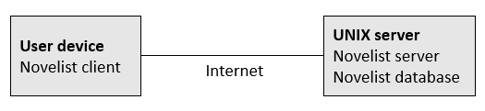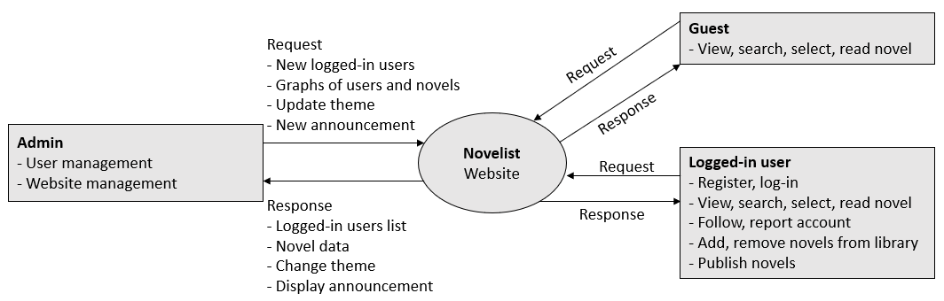

**4.2. Summary of Capabilities**

| **Customer Benefit** | **Supporting Features** |
| --- | --- |
| Access to website from any device | The system will have responsive interface and allow user to access from any device like laptop or mobile phone |
| Easy and timely searching for novel | Guest and logged-in user can search and view novel by providing name or type of novel |
| Secure and confidential | Logged-in user information is protected from unauthorized access |
| Access to website 24/7 | The system server will be supported to access 24/7 |

**4.3 Assumptions and Dependencies**

The assumption and dependencies relate to the capacities of Novelist website:

* Website will be available 24 hours a day, 7 days a week
* Website will be easy-to-use, customer will take less than an hour for using fluently
* Timely searching and take less than 1 second for each searching
* The system will have responsive interface and allow user to access from any device like laptop or mobile phone, PC

# Product Features

| ***No.*** | ***Feature*** | ***Description*** | ***Priority*** |
| --- | --- | --- | --- |
| 1. | Register | Novelist is available for guest and logged-in users, but if users access the website as guests, they’re not allowed to use all features like writing or uploading novels,...  So, they can register for new account, have an ID and password for this account | High |
| 2. | Change dark/light theme | Novelist will have dark/ light theme and allow to change for any user, guest | Low |
| 3. | Display, search, enter | Display novel at homepage, allow to read, search for any user | High |
| 4. | Account features | Logged-in users can vote, comment, share novels, add and remove novels to favorite list and library, change account preferences and information | High |
| 5. | Personal library | Users can create a list of their favorite novels and share them to other users | Low |
| 6 | Publish novel | The user can write and publish a novel for other users to read. | High |
| 7 | User management | For admins, they can ban or remove a user if they violate any rules. | High |
| 8 | Novel management | If a novel has been reported of violating rules, admins can review and decide whether or not to remove them. | High |
| 9 | Updating theme | Can change the overall theme of the web application depending on seasons, holidays, … | Low |
| 10 | Give announcement | Make an announcement to inform users. | High |

# Non-Functional Requirements

The non-functional relate to the capacities of Novelist website:

* The interface of website is easy-to-use, minimalist and take less than 1 hour for using fluently
* Searching time must be less than 1 second
* Access to website from any device
* User data must not be share to the third application